

A project report on

**Smart Irrigation System**

Team- 07

Submitted By

**Varshika, Emp Id. - 219745**

**Sujay Kumar Behera, Emp Id. - 219767**

**Avik Das, Emp Id. - 219771**

**Rohit Mallik, Emp Id. - 219830**

**Potnuru Rupsa, Emp Id. - 219660**

Submitted To

**Mohsin Khan A**

FEBRUARY 2023

**TABLE OF CONTENTS**

1. Abstract

2. Introduction

3. Proposed flowchart and schematic

4. Description of project working

5. Block Diagram

5. Hardware and software details

6. Applications

7. Advantages and disadvantages

8. Conclusion

9. Model snapshots & videos

**Abstract**

Irrigation stands out as one of the foremost consumers of freshwater within the agricultural sector. Surface irrigation, owing to its simplicity and minimal energy requirements, stands as one of the most widely embraced methods. In response to the critical issues of water scarcity and the efficient management of agricultural resources, the Smart Irrigation System introduces an innovative approach. By seamlessly integrating advanced sensor technologies, this system attains a heightened level of intelligence for monitoring soil conditions. This project involves the fusion of an LPC1768 microcontroller with soil moisture, temperature, and water level sensors for real-time environmental monitoring and smart irrigation. The microcontroller's Analog to Digital Converter is aptly configured to sample analog signals from the sensors, converting them into digital data. After acquiring sensor readings, the microcontroller processes the data, displaying real-time information on an LCD screen, and executing necessary actuations. This setup provides a convenient means to visualize and interpret environmental parameters in real-time. The intelligent oversight afforded by this system enables meticulous control over irrigation processes, facilitating targeted and efficient utilization of water resources. This comprehensive report delves into the system's evolution, diverse functionalities, and the myriad of potential applications it brings to the agricultural landscape. From revolutionizing traditional irrigation practices to promoting sustainable water usage, the Smart Irrigation System emerges as a pioneering solution, poised to redefine our approach to resource management in agriculture. The integration of cutting-edge sensor technologies not only addresses current challenges but also opens doors to a more resilient and adaptive agricultural future.

**Introduction**

The Smart Irrigation System presented in this project report leverages the LPC1768 microcontroller. Onboard the LPC1768 microcontroller is a 32-bit ARM Cortex M3 processor. The board also has a 12-bit analog-to-digital converter (ADC) with 8 separate channels. This microcontroller serves as the central hub for integrating cutting-edge sensor technologies, namely the LM35 temperature sensor, YL 69 resistive soil moisture sensor, and a water level sensor. These sensors are strategically connected to the ADC channels 1(AD0.1), 2 (AD0.2), and 3 (AD0.3), respectively.

The LM35 temperature sensor provides accurate temperature readings by converting analog signals into digital data, offering a real-time assessment of environmental conditions. Simultaneously, the YL 69 soil moisture sensor, with its resistive soil moisture measurement capability, enhances the system's intelligence by monitoring soil conditions effectively.

Moreover, the water level sensor, interfaced with the ADC channel 4, contributes to comprehensive environmental monitoring by ensuring that the water resource level is efficiently tracked. This sensor fusion approach allows the Smart Irrigation System to attain a heightened level of intelligence, enabling precise and targeted control over irrigation processes.

The LPC1768 microcontroller is configured to handle the intricacies of these sensor inputs through its ADC, enabling the conversion of analog signals to digital data. The project employs the microcontroller's capabilities to process and display real-time information on an LCD screen. Additionally, a UART interface facilitates communication, providing an alternate means to access the data.

The brilliance of the Smart Irrigation System lies in its ability to trigger irrigation only when necessary, conserving water resources and minimizing the risk of over-irrigation, which can lead to environmental harm. Aligned with eco-friendly agricultural practices, the system promotes sustainable water usage, benefiting both the environment and addressing economic concerns related to water scarcity. In essence, it represents a beacon of innovation, harmonizing technology and environmental consciousness. It empowers farmers with intelligent oversight, promoting sustainable water usage and revolutionizing the way we manage agricultural resources.

**Proposed Flowchart & Schematic**

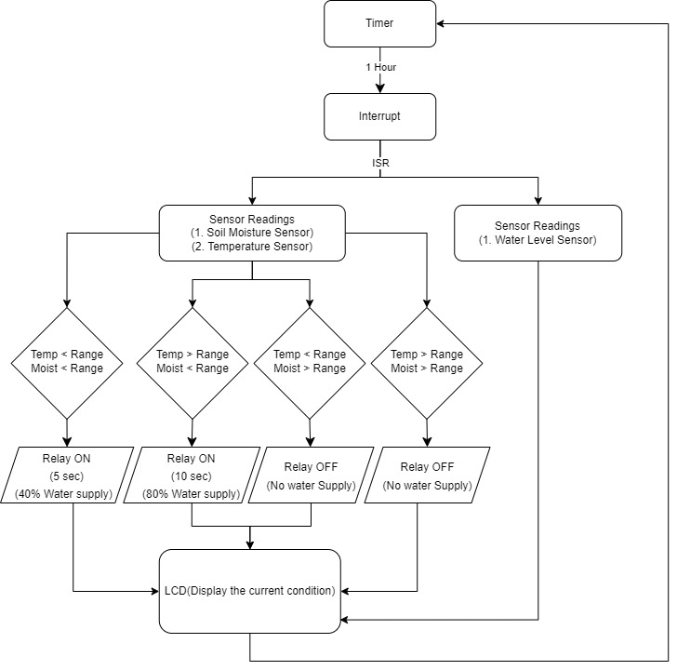

Fig.1. Flow Chart Of The System

**Description of Project Working**

The Smart Integration System is a clever project that combines the LPC1768 microcontroller with sensors for temperature, humidity, and water levels. These sensors help keep an eye on what's happening in the environment around them.

Using the LPC1768 microcontroller, the system can understand the information from these sensors and decide what to do based on it. For instance, If the humidity gets too high, it could activate a dehumidifier. And if the water level drops too low, it might trigger a pump to fill the tank back up.

Overall, the Smart Integration System is like having a smart assistant that helps manage and control the environment around you, whether it's at home, in a factory, or on a farm. It makes things easier by automating tasks and keeping everything running smoothly.

In our project, we used:

1. The Timer 0 inside the LPC1768 is used to check the sensor readings after a fixed interval of 1 hour.
2. When the value of Match Control Register 0 (MR0) of Timer 0 matched with the TC (Timer Counter). An interrupt is sent. And the program enters the Interrupt Service Routine (ISR).
3. Inside the ISR (TIMER0_IRQHandler) soil moisture, temperature, and water level are checked serially.
4. The Soil moisture sensor connected to channel 3 is the ADC (P0.26).
5. Then considering the block diagram that is given above, we have 4 cases. We have set a particular threshold for moisture and temperature.
   1. Temperature < threshold, Moisture < threshold
   2. Temperature > threshold, Moisture < threshold
   3. Temperature < threshold, Moisture > threshold
   4. Temperature > threshold, Moisture > threshold
6. Accordingly, the relay will be switched on for the given duration.
7. After the task is completed, the ISR will finish and the program will return to the timer.
8. After 1 hour, the process will repeat.

**Block Diagram**

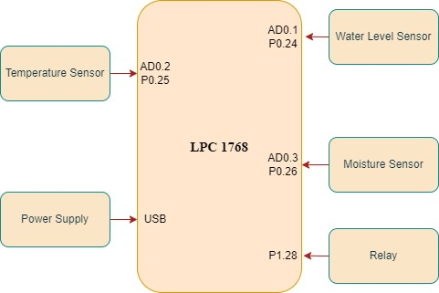

Fig.2. Block Diagram Of The System

**Hardware and Software Details**

**Hardware:-**

1. **Temperature Sensor:**

The LM35 temperature sensor is a versatile and accurate tool widely utilized in smart irrigation systems, offering precise soil temperature monitoring for optimized watering schedules and resource conservation. With linear output and high accuracy across a broad temperature range (-55°C to +150°C), the LM35 simplifies integration into microcontroller-based systems and ensures reliable temperature measurements. Its low power consumption and ease of use make it ideal for various applications, including adaptive watering, frost protection, and disease control in agricultural settings. By leveraging the LM35's capabilities, smart irrigation systems can enhance efficiency, improve crop health, and reduce manual intervention, leading to sustainable resource management and higher yields.

1. **Moisture Sensor:**

The YL-69 soil moisture sensor is a cost-effective and reliable tool for smart irrigation systems, operating by measuring soil conductivity to determine moisture levels. Offering dual output modes, adjustable sensitivity, and corrosion-resistant materials, it enables real-time moisture monitoring and automated watering based on predefined thresholds. By preventing overwatering and ensuring optimal moisture levels for plant growth, the YL-69 promotes water conservation, plant health, and efficient resource management. Easy integration and calibration further enhance its usability, making it a valuable component for enhancing irrigation efficiency and reducing costs in agricultural applications.

1. **Relay:**

In a smart irrigation setup with an LPC1768 microcontroller, pin 28 typically connects to a relay for controlling irrigation valves, pumps, or actuators. This relay, managed through software control, enables automation of watering based on sensor data and user-defined parameters. Hardware connections involve linking the relay module's coil to pin 28 and ground, with the actuator connected to the relay's contacts. Software-wise, pin 28 is configured as a GPIO output, allowing for relay activation (logic high) and deactivation (logic low) based on watering logic derived from sensor inputs and predefined rules. This integration facilitates efficient irrigation management, blending sensor-driven decision-making with timed control for optimal plant hydration and resource conservation.

1. **Water Level Sensor:**

The Water Level Sensor offers versatile functionality including water level measurement, sump pit monitoring, rainfall detection, and leak detection. It operates via interlaced copper traces that form a variable resistor, whose resistance changes based on water immersion depth. This variation inversely correlates with immersion depth: more immersion improves conductivity and lowers resistance, while less immersion reduces conductivity and increases resistance. The sensor provides an output voltage proportional to the resistance, facilitating water level determination. Its straightforward integration requires connection to three pins: Signal (analog output), + (VCC) for power (recommended 3.3V to 5V), and - (GND) for ground. To extend sensor lifespan and minimize corrosion, it's advisable to power the sensor only during readings. Achieve this by connecting the + (VCC) pin to an Arduino's digital pin (#7), toggling it HIGH or LOW as needed, and connecting the S (Signal) pin to an analog input pin (A0) for data acquisition.

1. **Microcontroller:**

The LPC1768 is a versatile 32-bit ARM Cortex-M3 microcontroller renowned for its extensive peripheral set and high-performance capabilities. Featuring a clock speed of up to 100 MHz, it offers ample processing power for diverse embedded applications. With 512 KB of flash memory and 64 KB of RAM, it accommodates complex firmware and data storage requirements. The LPC1768 supports a variety of communication interfaces including UART, SPI, I2C, and USB, facilitating seamless connectivity with peripherals and external devices. Its rich feature set includes timers, PWM channels, analog-to-digital converters, and GPIO pins, enabling versatile control and sensing capabilities. The microcontroller operates within a wide voltage range and boasts low power consumption, making it suitable for both battery-operated and mains-powered applications. It is widely utilized in industries such as consumer electronics, automotive, industrial automation, and IoT for its reliability, performance, and extensive community support.

1. **Power Supply:**

During the development phase of this Smart Irrigation System module, we use flash magic to conveniently program the microcontroller. However, for real-world deployments, the system would rely on a sustainable and portable power source like:

* Batteries: Long-lasting, readily available batteries can provide reliable power, especially for smaller irrigation systems. Choose rechargeable batteries and incorporate charging mechanisms for long-term use and to minimize waste.
* Solar panels: Harnessing solar energy offers an eco-friendly and self-sufficient power solution. Consider factors like sunlight availability, panel size, and energy storage needs when designing your system.

**Software:-**

1. **Programming Language:**

C is a powerful programming language widely used for embedded systems, including the LPC1768 microcontroller. With C, developers can write efficient and portable code to control hardware peripherals, handle interrupts, and manage memory. LPC1768 coding involves configuring registers and utilizing libraries provided by the microcontroller manufacturer to access hardware features like GPIO, UART, SPI, and ADC. Developers leverage C's syntax and constructs to implement algorithms, handle real-time events, and interact with external devices. The language's simplicity and versatility make it well-suited for low-level programming tasks required in embedded systems development. Understanding C fundamentals, data types, pointers, and memory management is essential for effective LPC1768 coding, enabling the creation of robust and efficient firmware for various applications.

1. **Microcontroller Platform:**

Keil is an IDE for LPC1768 programming, offering tools for writing, compiling, debugging, and simulating embedded software. It simplifies development with its intuitive interface and comprehensive features.

Flash Magic is a tool for LPC1768 firmware programming via UART or ISP interfaces. It supports diverse LPC1768 configurations and provides features for erasing, programming, and verifying flash memory. Its user-friendly interface is preferred for firmware deployment in embedded systems.

**Applications**

The project has numerous applications across various domains, owing to its ability to monitor critical environmental parameters in real-time. In agriculture, the system can be utilized to optimize irrigation schedules by monitoring soil moisture levels, ambient temperature, and water level. This ensures that crops receive adequate water, improving yields and water efficiency.

Some key applications are:-

1. **Agriculture**
   1. **Crop cultivation:** Smart irrigation systems can significantly benefit crop cultivation by providing precise irrigation schedules tailored to specific crop needs.
   2. **Greenhouses:** In greenhouse environments, where conditions are tightly controlled, smart irrigation systems can maintain ideal moisture levels and temperature for plant growth.
   3. **Orchards and Vineyards:** Orchards and vineyards can benefit from smart irrigation systems to ensure optimal soil moisture levels for fruit and grape production.
2. **Landscaping and Turf Management**
   1. **Parks and Recreational Areas:** used to maintain lush greenery in parks and recreational areas while conserving water resources.
3. **Urban and Residential Landscapes:**
   1. **Residential Gardens**: Homeowners can utilize this system to maintain gardens and lawns efficiently.
4. **Environmental Monitoring:**
   1. **Remote monitoring:** Farmers can remotely monitor their crops and take necessary actions to boost productivity.
   2. **Ecosystem Restoration:** Smart irrigation systems can be deployed in ecological restoration projects to establish vegetation and stabilize soil in degraded landscapes.

In industrial automation, the system can be integrated into manufacturing processes to monitor temperature levels and ensure optimal operating conditions. By maintaining consistent temperatures, the system can enhance product quality and efficiency while minimizing energy consumption.

Furthermore, the system finds applications in environmental monitoring, where it can be deployed in research stations or wildlife habitats to track changes in moisture and temperature levels. This enables scientists to study environmental patterns and assess the impact of climate change on ecosystems.

Additionally, the system can be used in home automation setups, where it integrates with smart home systems to provide climate control functionalities. Users can monitor indoor temperature and humidity levels, ensuring comfort and energy efficiency.

Overall, the project's applications span diverse fields, including agriculture, industry, environmental science, and home automation, showcasing its versatility and utility in various real-world scenarios.

**Advantages and Disadvantages**

**Advantages:**

* Precise watering: The system ensures optimal water usage, reducing waste.
* Automation: Minimal human intervention is required, leading to increased efficiency.
* Improved Crop Yield: Precise irrigation enhances crop growth and yield.
* Reduced water waste: By only watering when necessary, smart systems can significantly reduce water usage compared to traditional timers or manual methods.
* Remote control and monitoring: Systems can be controlled and monitored remotely via apps or web interfaces, eliminating manual watering tasks and allowing adjustments based on changing conditions.
* Time-saving: Automate routine watering tasks, freeing up time and effort for other activities.
* Data-driven insights: Historical data helps analyze watering patterns and make informed decisions for future optimization.
* Reduced disease and pest issues: Proper watering minimizes stress and promotes healthier plants, potentially reducing susceptibility to diseases and pests.
* Environmental benefits: Water conservation efforts contribute to sustainability and ecosystem health.

**Disadvantages:**

* Initial Cost: Implementation may involve an initial investment in sensors and technology.
* Dependency on Sensors: The system's effectiveness relies on the accuracy of sensor readings.
* Complexity: Requires technical knowledge or professional installation, especially for complex systems. Sensors and technology components may require occasional maintenance or troubleshooting.
* Learning curve: Understanding and managing the system might require some learning effort for users unfamiliar with technology.
* Limited compatibility: Some systems might not be compatible with all existing irrigation infrastructure.

**Model Snapshots & Videos**

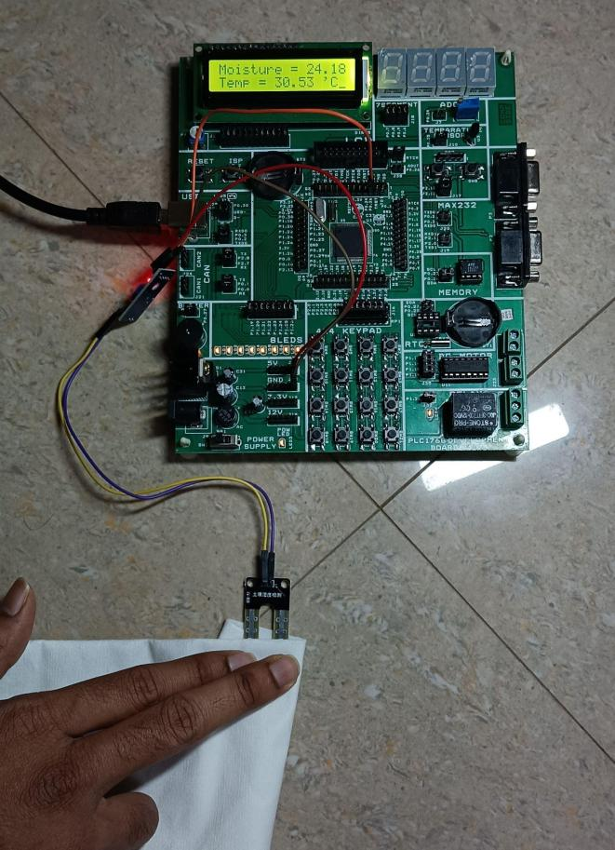

Fig.3. Hardware demonstration of Soil moisture sensor (YL69) and

temperature sensor (LM35). The real-time values are shown on the LCD.

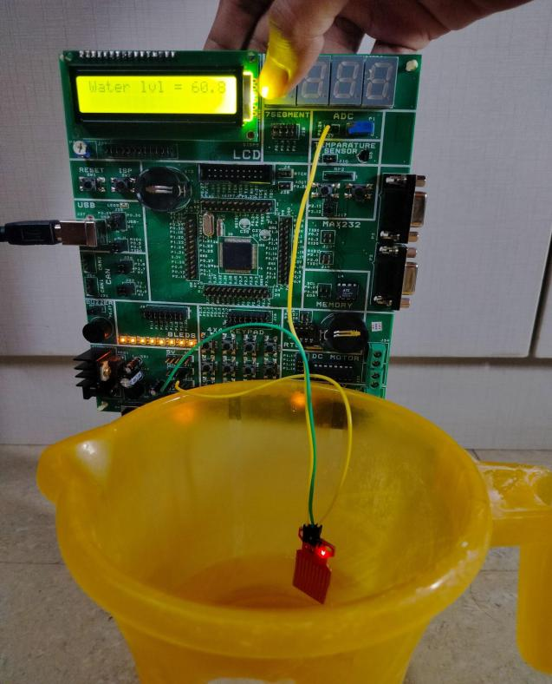

Fig.4. Hardware demonstration of Water level sensor.

The real-time values are shown on the LCD.

**Conclusion**

The Smart Irrigation System marks a crucial advancement in fostering sustainable agriculture. Through its integration of technology to monitor and respond to soil conditions, the system not only addresses concerns related to water scarcity but also significantly improves crop productivity. The project's insights offer valuable lessons for the future development of precision agriculture. This innovative approach, combining real-time data analysis with efficient irrigation practices, contributes to the ongoing efforts to create more resource-efficient and environmentally conscious farming methods. As a beacon of progress, the Smart Irrigation System stands poised to shape the trajectory of modern agriculture, emphasizing the importance of technological solutions in achieving sustainable and productive outcomes.